Web Engineering Lab 1

Name: Nisha Kumari
Cms I’d: 023-24-0178
Section: F

Class Activity A
draw the client server diagram with pen and paper
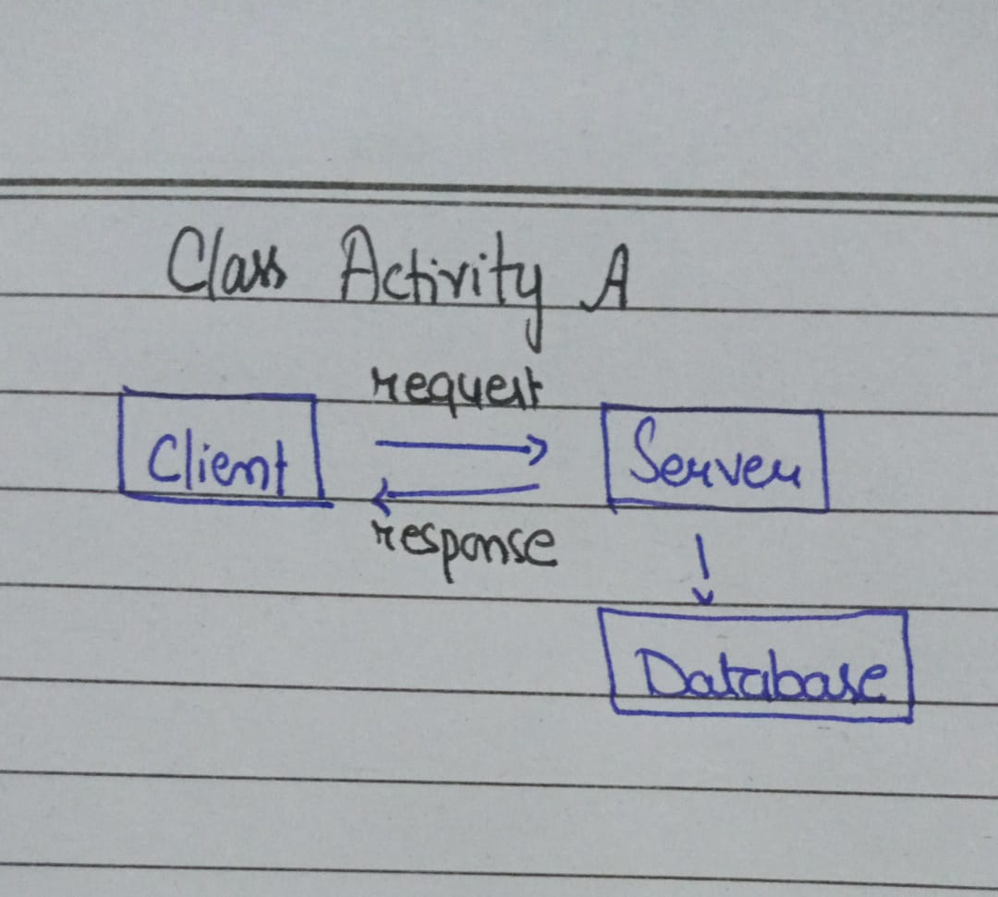

Class activity B — URL teardown
https://example.com:443/products/42?sort=price#reviews
Protocol: https
Host: example.com
Port: 443
Path: /products/42
Query: ?sort=price
Fragment: #reviews

http://127.0.0.1:5500/index.html
I changed the page from index.html to another HTML file. When I changed the page, the path part of the URL changed from /index.html to the new file name.
Activity C — HTTP Status Codes
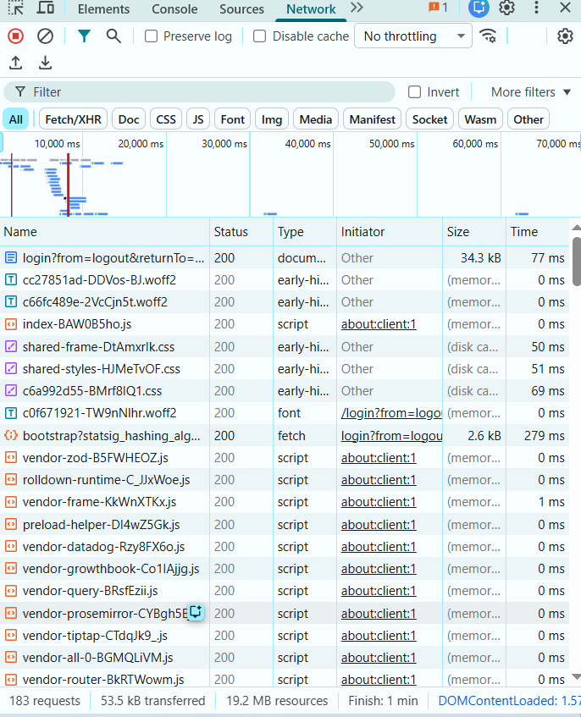
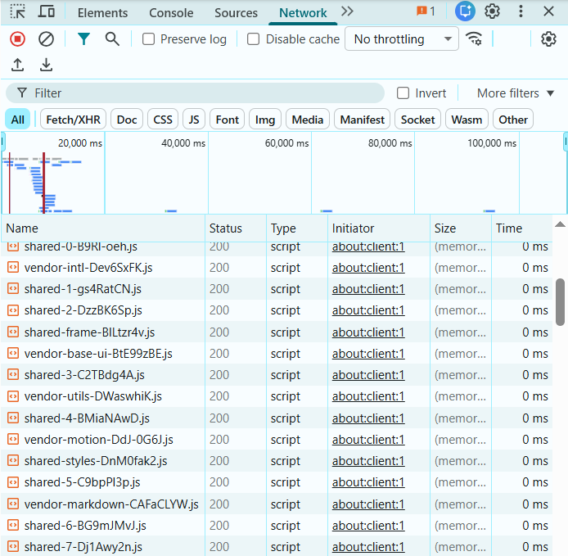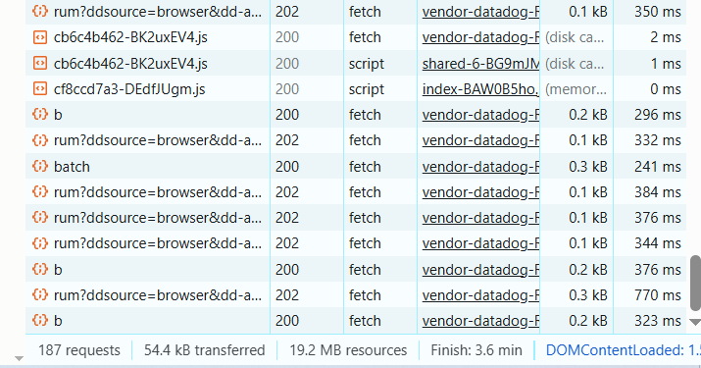
Class activity E — personalise and serve
<!DOCTYPE html>
<html lang="en">
<head>
<meta charset="UTF-8" />
<meta name="viewport" content="width=device-width, initial-scale=1.0" />
<title>Hello Web</title>
</head>

<body>
<h1>Hello, Web Engineering</h1>

<p>
My name is Nisha. I am learning web engineering and this is my first
web page.
</p>

<p>
I am computer Science Student at Sukkur IBA Univeristy
</p>

<h2>Things I Want to Build</h2>

<ul>
<li>My first web application</li>
<li>A personal portfolio</li>
<li>A full-stack project</li>
<li>Compiler</li>
</ul>

<button id="greet">Click me</button>

<script>
document.getElementById("greet").addEventListener("click", () => {
alert("The button works.");
});
</script>
</body>
</html>
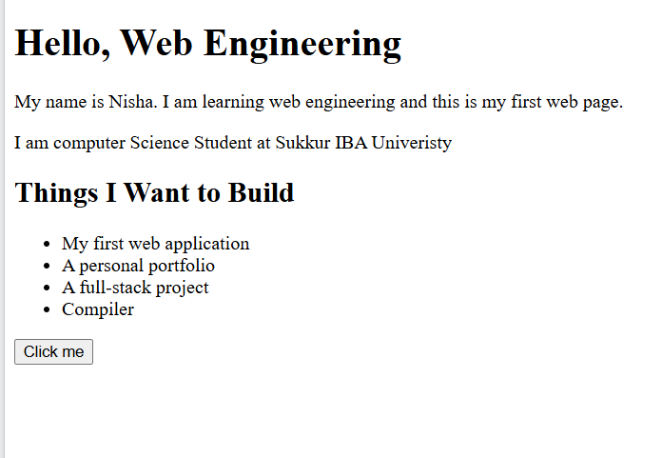
Class activity F — three DevTools drills
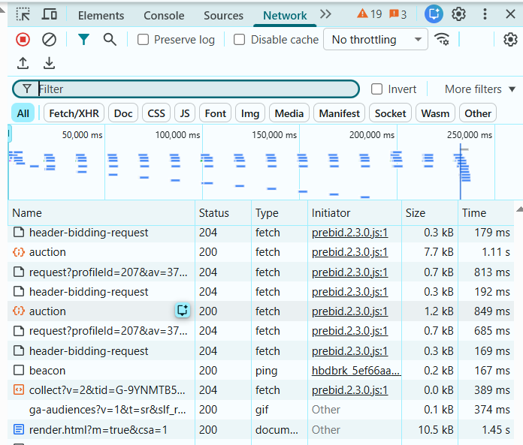
Console: Type
document.title
and press Enter. Check the result.
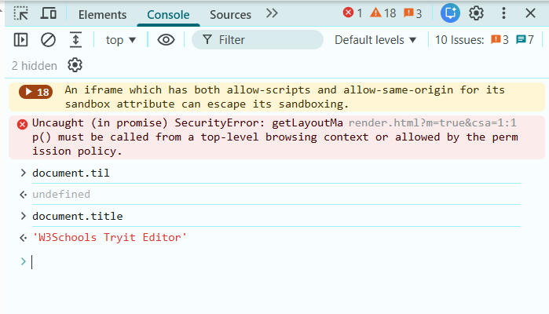

after ctrl+R
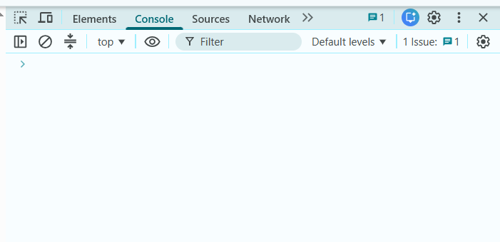
Why did it disappear?
Editing HTML through DevTools does not automatically modify the original source file.
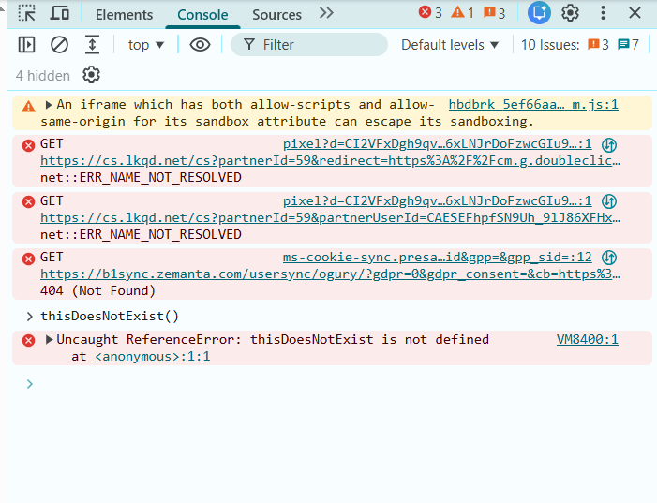
The Console shows a ReferenceError because I tried to call thisDoesNotExist(), but that function has not been defined.

